Date | 30September 2026
TeamID | 6ab4dd7a6f290be8a6b49f92
ProjectName | Script-Controlled ACL – Restrict Record Access Based on Field Value
Maximum Marks | 3 Marks

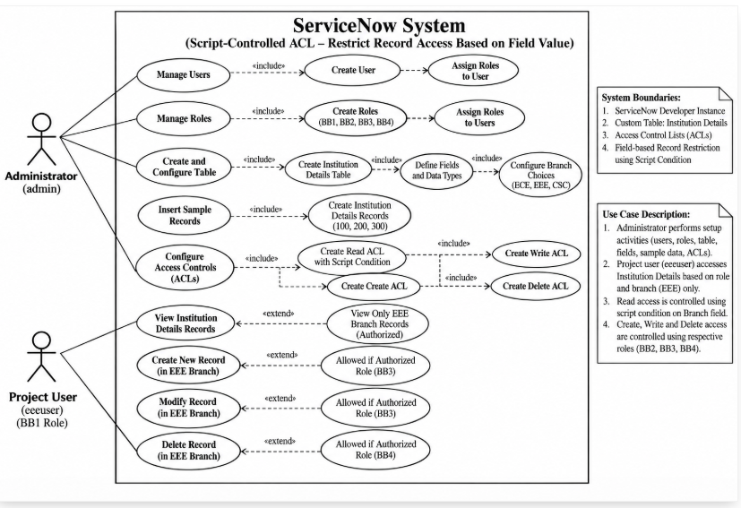
The Use Case Diagram illustrates the interactions between the Administrator, Project User, and the ServiceNow system. The Administrator manages users and roles, creates and configures the Institution Details table, defines fields and branch choices, inserts sample records, and configures the required ACLs for Read, Create, Write, and Delete operations. The Project User accesses, creates, modifies, or deletes Institution Details records only when the corresponding role and ACL conditions permit the operation. The diagram also shows the field-based restriction that allows authorized access to EEE branch records while restricting unauthorized records.

